Image Database
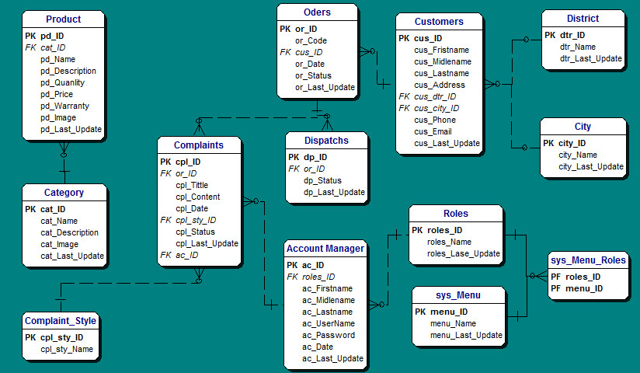

Diagram
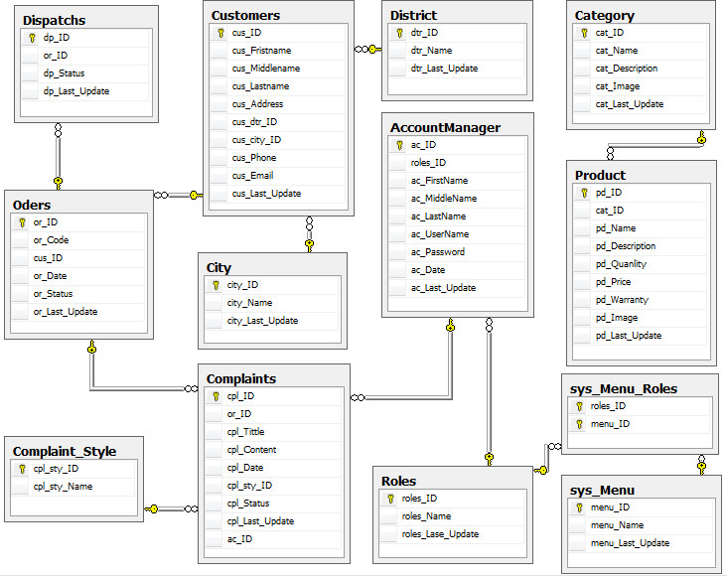

Description
Account Manager
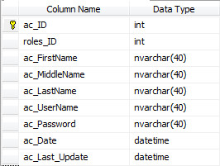
No. | Field Name | Description
01 | ac_ID | Number of Account (auto increment)
02 | roles_ID | Number of roles
03 | ac_FristName | Frist name of Account
04 | ac_MiddelName | Middle Name of Account
05 | ac_LastName | Last Name of Account
06 | ac_UserName | User Name of Account
07 | ac_Password | Password of Account
08 | ac_Date | The day create this Account
09 | ac_Last_Update | The last day update information

Category
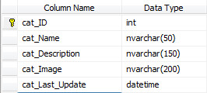
No. | Field Name | Description
01 | cat_ID | Number of this category
02 | cat_Name | Category Name
03 | cat_Description | Description of category
04 | cat_Image | Image of this category
05 | cat_Last_Update | The last day update information

City
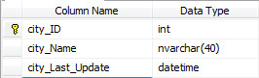
No. | Field Name | Description
01 | city_ID | Number of city
02 | city_Name | Name of city
03 | city_Last_Update | The last day update information

Complaint
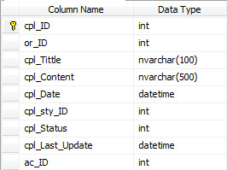
No. | Field Name | Description
01 | cpl_ID | Number of Complaint
02 | or_ID | Number of Order
03 | cpl_Tittle | Tittle of complaint
04 | cpl_Content | Content of complaint
05 | cpl_Date | The day create this complaint
06 | cpl_sty_ID | Number of complaint style
07 | cpl_Status | Status of complaint
08 | cpl_Last_Update | The last day update information
09 | ac_ID | Number of account

Complaint Style
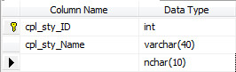
No. | Field Name | Description
01 | cpl_sty_ID | Number of Complaint style
02 | cpl_sty_Name | Name of Complaint style

Customer
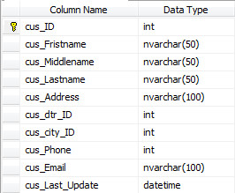
No. | Field Name | Description
01 | cus_ID | Number of customer
02 | cus_Fristname | Frist name of customer
03 | cus_Middlename | Middle name of customer
04 | cus_Lastname | Last name of customer
05 | cus_Address | Address of customer
06 | cus_dtr_ID | Number district of customer
07 | cus_city_ID | Number city of customer
08 | cus_Phone | Phone number of customer
09 | cus_Email | Email of customer
10 | cus_Last_Update | The last day update information

Dispatch
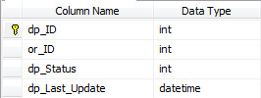
No. | Field Name | Description
01 | dp_ID | Number of dispatch
02 | or_ID | Number of Order
03 | dp_Status | Status of dispatch
04 | dp_Las_Upate | The last day update information
District
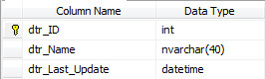
No. | Field Name | Description
01 | dtr_ID | Number of district
02 | dtr_Name | Name of district
03 | dtr_Last_Update | The last day update information

Menu
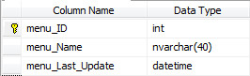
No. | Field Name | Description
01 | menu_ID | Number of menu
02 | menu_Name | Name of menu
03 | menu_Last_Update | The last day update information

Order
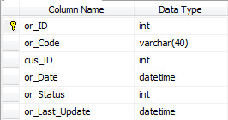
No. | Field Name | Description
01 | or_ID | Number of order
02 | or_Code | Code of order
03 | cus_ID | Number of customer
04 | or_Date | The day create this order
05 | or_Status | Status of order
06 | or_Last_Upate | The last day update information

Product
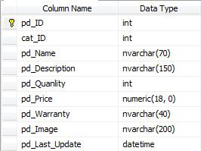
No. | Field Name | Description
01 | pd_ID | Number of product
02 | cat_ID | Number of category
03 | pd_Name | Product name
04 | pd_Descriptiom | Description of product
05 | pd_Quanlity | Quanlity of product
06 | pd_Pirce | Price of product
07 | pd_Warranty | Warranty of product
08 | pd_Image | Image of product
09 | pd_Last_Update | The last day update information

Roles Menu
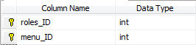
No. | Field Name | Description
01 | poles_ID | Number of roles
02 | menu_ID | Number of menu

Roles
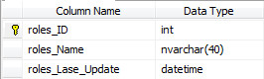
No. | Field Name | Description
01 | roles_ID | Number of roles
02 | roles_Name | Name of roles
03 | roles_Last_Update | The last day update information

